Indicator 7: Early Childhood Outcomes, 2021
Percent of children with IEPs who demonstrate improved:
- Positive social-emotional skills (including social relationships)
- Acquisition and use of knowledge and skills (including early language/ communication and early literacy)
- Use of appropriate behaviors to meet needs

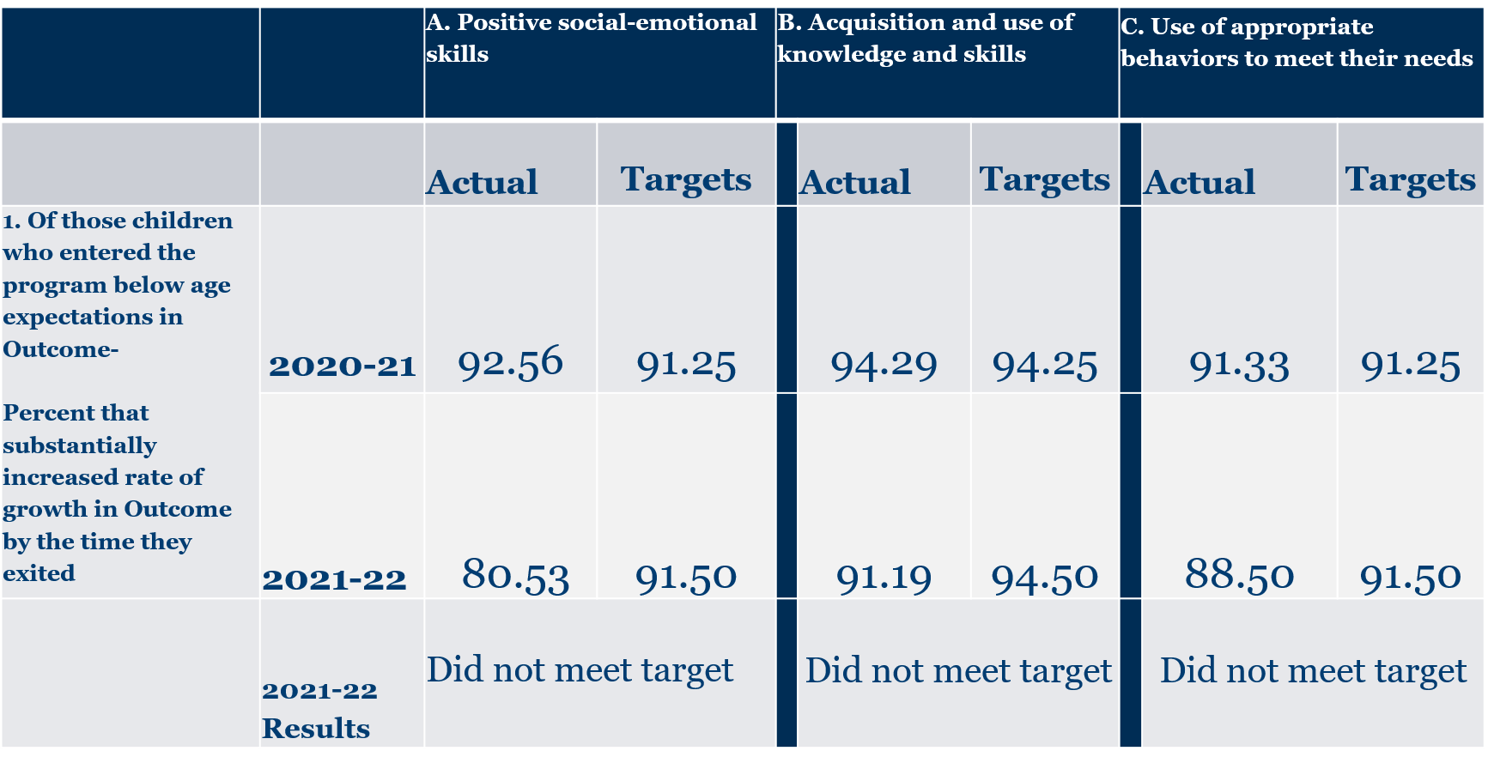

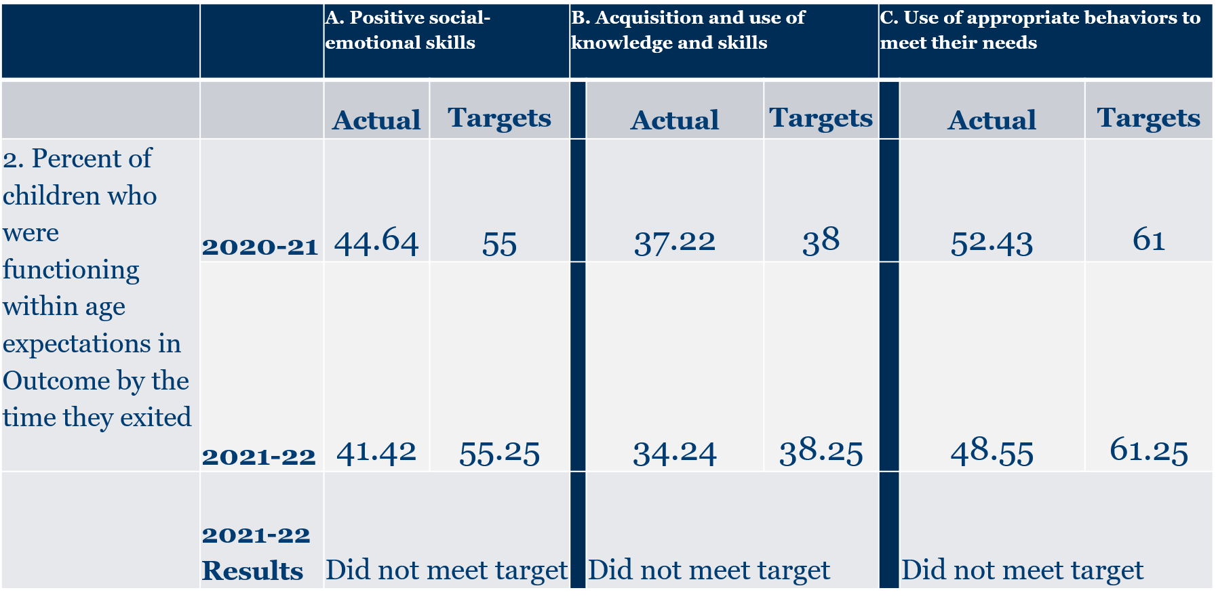
Data are from the 2020-2021 school year.
1. Social-emotional skills
a. Of those children who entered the program below age expectations in Outcome, the percent that substantially increased rate of growth in Outcome by the time they exited.
State Target: 91.50%
State Data: 80.53%
Did not meet target

b. Percent of children who were functioning within age expectations in Outcome by the time they exited.
State Target: 55.25%
State Data: 41.42%
Did not meet target

2. Acquisition and use of knowledge and skills
a. Of those children who entered the program below age expectations in Outcome, the percent that substantially increased rate of growth in Outcome by the time they exited.
State Target: 94.50%
State Data: 91.19%
Did not meet target

b. Percent of children who were functioning within age expectations in Outcome by the time they exited.
State Target: 38.25%
State Data: 34.24%
Did not meet target

3. Use of appropriate behaviors to meet needs
a. Of those children who entered the program below age expectations in Outcome, the percent that substantially increased rate of growth in Outcome by the time they exited.
State Target: 91.50%
State Data: 88.50%
Did not meet target

b. Percent of children who were functioning within age expectations in Outcome by the time they exited.
State Target: 61.25%
State Data: 48.55%
Did not meet target

*This is preliminary data and will be reviewed and confirmed by the Virginia Department of Education (VDOE) and Office of Special Education Programs

